**Egress-Only Internet Gateway**

So I mentioned in the previous lesson that all IP version six IP addresses are publicly accessible and so you can't use Nat gateways with IP version six addresses from one hand, it's not needed and from the other hand, it's not supported. So you don't have the option of using NAT gateways with any instances that you want to keep private using IP version six. By default, if you've got an instance that users an IP version six address, then if you just use internet gateways then communication is possible in a bidirectional way with that instance. So that instance can communicate with the public internet but the public internet can also communicate with that instance using IP version six. Egress-only internet gateways offer an alternative. Essentially, for every major piece of functionality, they're the same as an internet gateway so they're created in exactly the same way. We go to egress-only internet gateways. We create one would select a VPC in this case, VPC1 and hit create. That means this egress-only gateway is now created, and it's associated with a specific VPC. To use it we would have to edit the route table. So we go to route tables. We'd pick a specific route table in our VPC. So for this high level demonstration, I might select route table private A and go to routes, edit route, add route, pick an IP version six route in most cases, this would be the default route, so ::/0 then pick egress only gateway. Select that and click on Save. **Now at that point, that would mean that any IP version six capable instance inside this subnet to which this route table applies so any of the associated subnets The instance could communicate in an outbound way with the public IP version six internet on the receive response traffic, but what it would not allow would be for any public IP version six endpoints on the internet to initiate communications with this instance, so it essentially provides an outgoing only version of an internet gateway. That's why it's called an egress-only internet gateway**. You just need to know that it exists. I'm not going to go into any more detail at an associate level. **Essentially, it provides outgoing only access for IP version six capable instances. You create it. You attach it to a VPC. You add an IP version six default route that points at this egress-only gateway and then any instances affected by that route table can access the IP version six public internet in an outgoing only way, but the reverse is not allowed.**

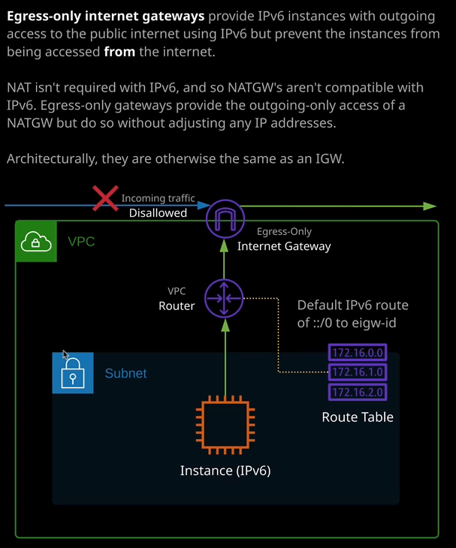

So this architecture diagram we've assigned the egress only gateway to the VPC. This instance, which is IP version six capable using a default IP version six route on the route table it can access the IP version six internet but any incoming traffic is dropped at this egress-only gateway. So at an associate level, that's all you need to do. You just need to be aware that functionality exists, that it's used with IP version six. You need to know its architecture and exactly what it does.